Assignment 3 Coin Detection

# Pola Moussa 23

**Mohamed Abo-shamaa 50**

# Code explanation and detailing

Color array of 3 different colors to identify different coins

colors01=[[255,0,0],[0,255,0],[0,0,255]]

loop on the input pictures array

for i in range(0,NoOfRuns):

copying the image to print the identifying coloring circles on it

final = img1.copy()

initial processing for the image to detect the coin edges

img\_grey=cv2.cvtColor(img1,cv2.COLOR\_BGR2GRAY)

smoothed=cv2.medianBlur(img\_grey,7)

edged=cv2.Canny(smoothed,250,280)

height, width = edged.shape

array for different coin radii

R=[107,120,135]

create a zero array to accumulate the Hough space on it

Hough = np.zeros((height, width), dtype=np.uint8)

Looping to accumulate the Hough and vote for center points

for k in range(0,height):

for j in range(0,width):

if (edged[k][j]==255):

circles = np.zeros((height, width), dtype=np.uint8)

cv2.circle(circles, (j,k), R[l], 1, 1)

Hough=Hough+circles

Process the Hough space to extract the center points

lk=Hough.ravel()

maxOne=max(lk)

for k in range(0,height):

for j in range(0,width):

if(Hough[k][j]>maxOne-30):

cv2.circle(final, (j,k), R[l], colors01[l], 20)

# Hough Space accumulator illustration:

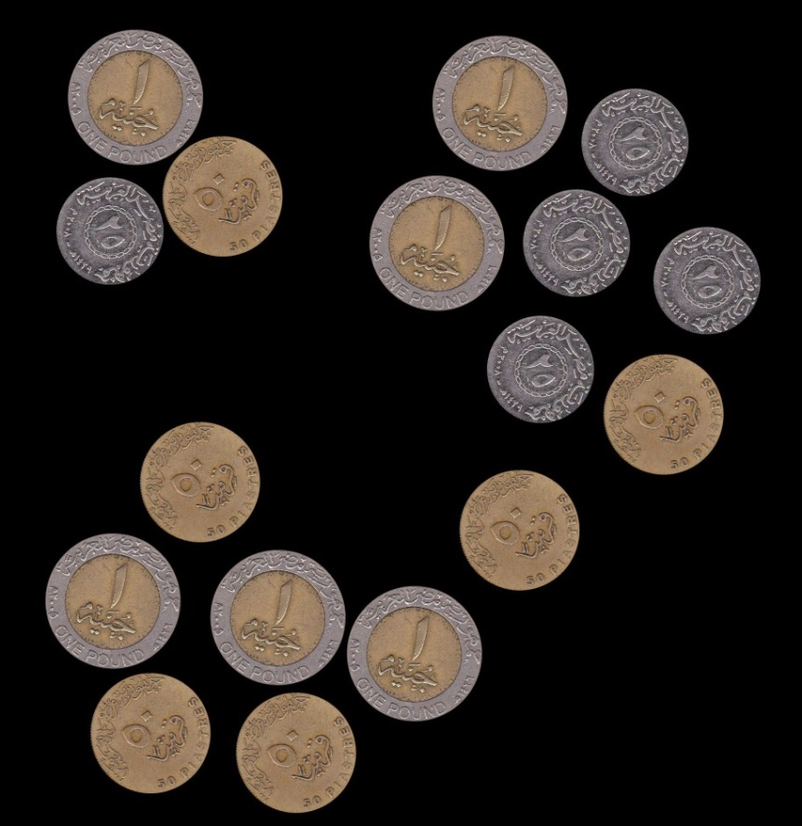

The original image where we have 5 coins of the monetary value 25 piasters

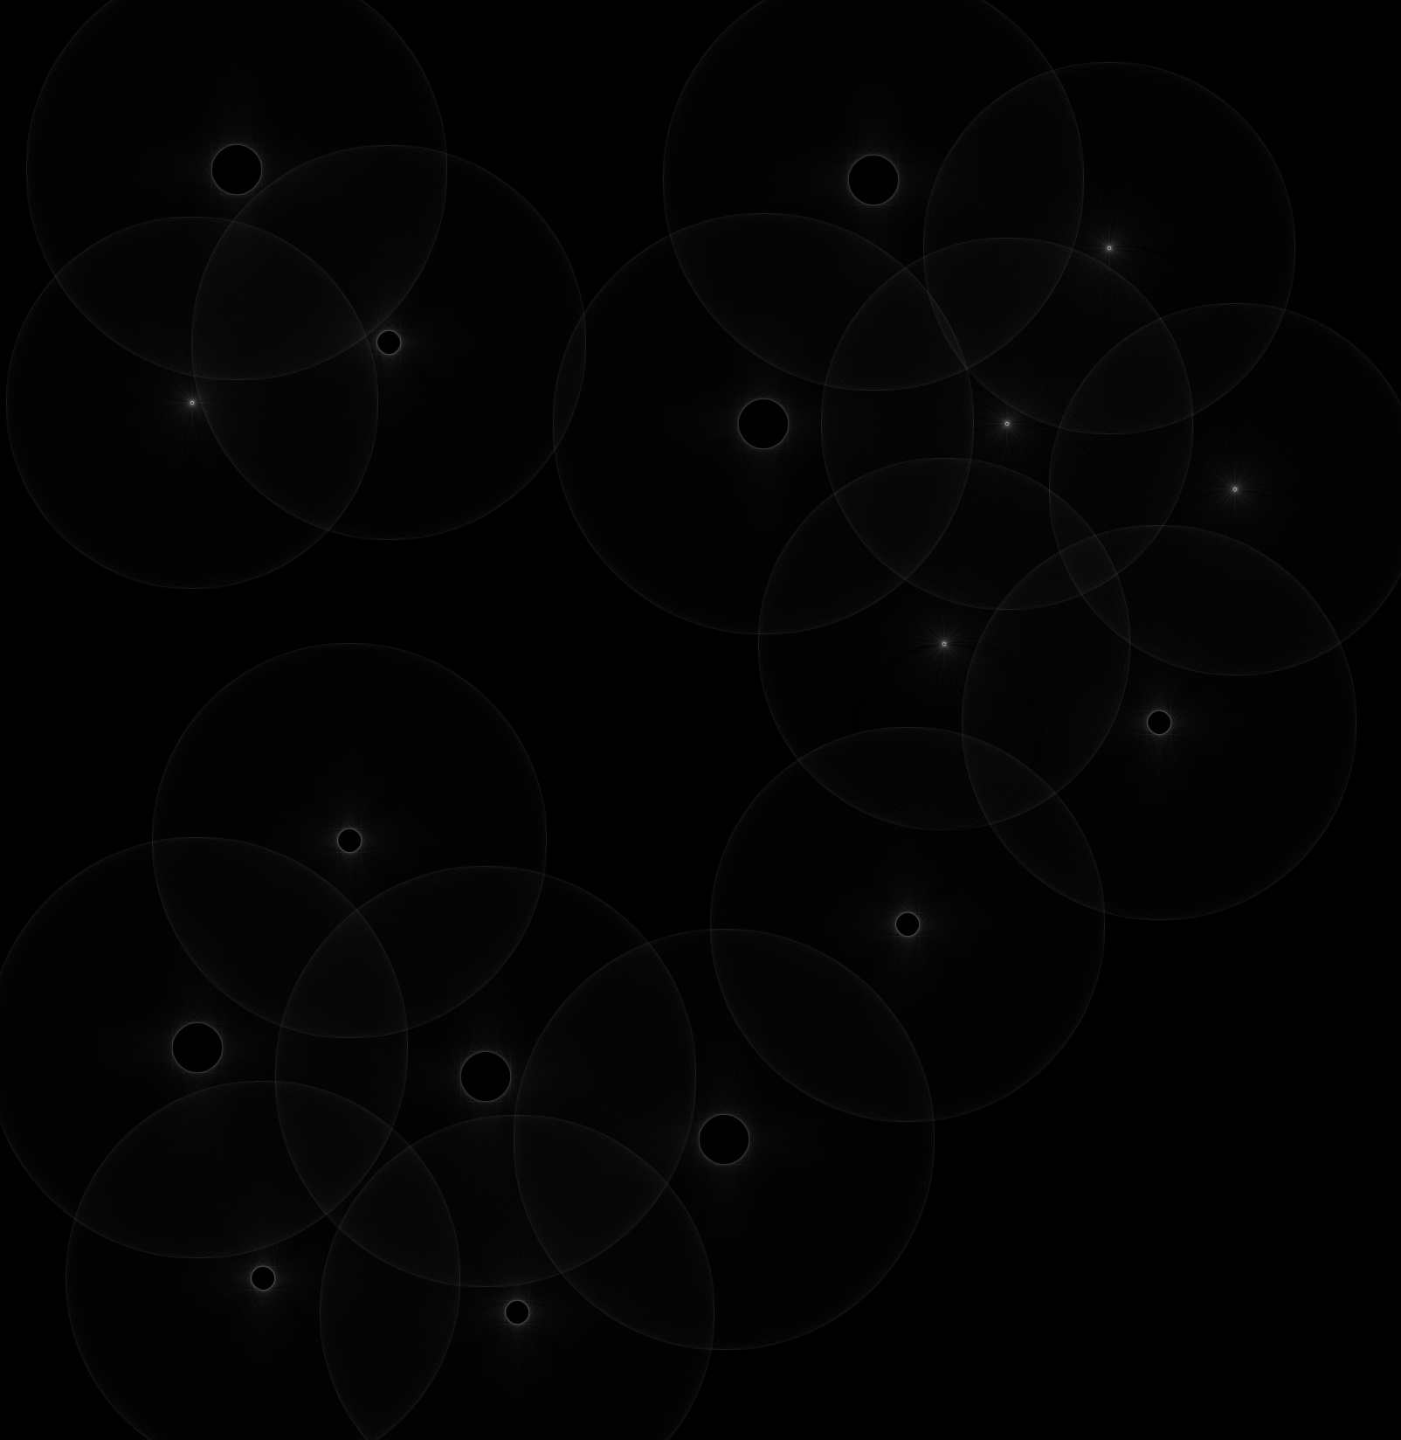

The corresponding Hough space after deploying the CHT algorithm for detecting the coins of 0.25 monetary value we see 5 points where the coins centers are located in the original one

# Impact of the Bin size

It is noticed that as the bin size increase the processing time increase however the accuracy of the detected edges also increase

# Sample Outputs

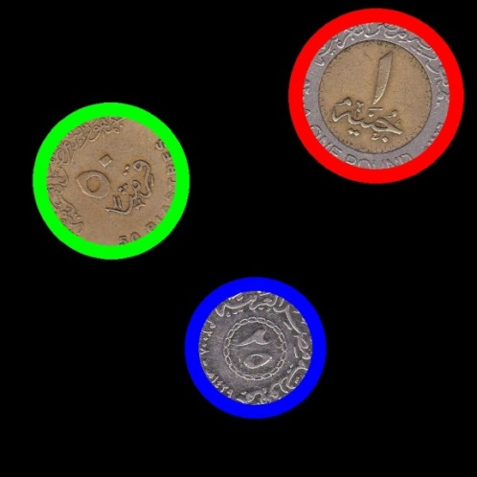 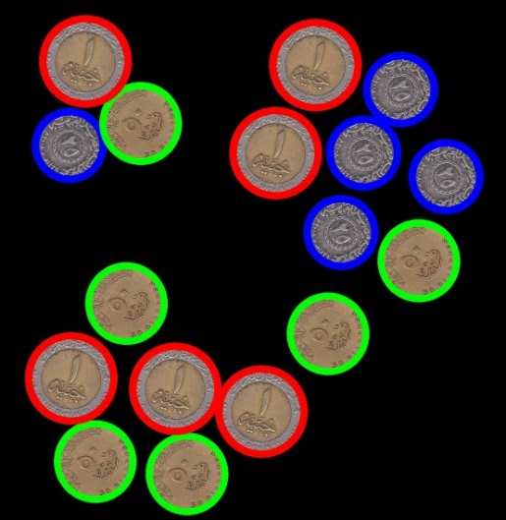

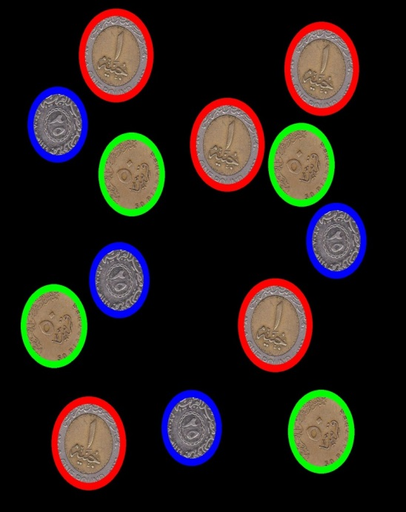

Example of Circle Hough spaces for different circle radii

# C:\Users\pola\Ass3\coins_6R120Hough.jpg

Hough for 50 piasters coins

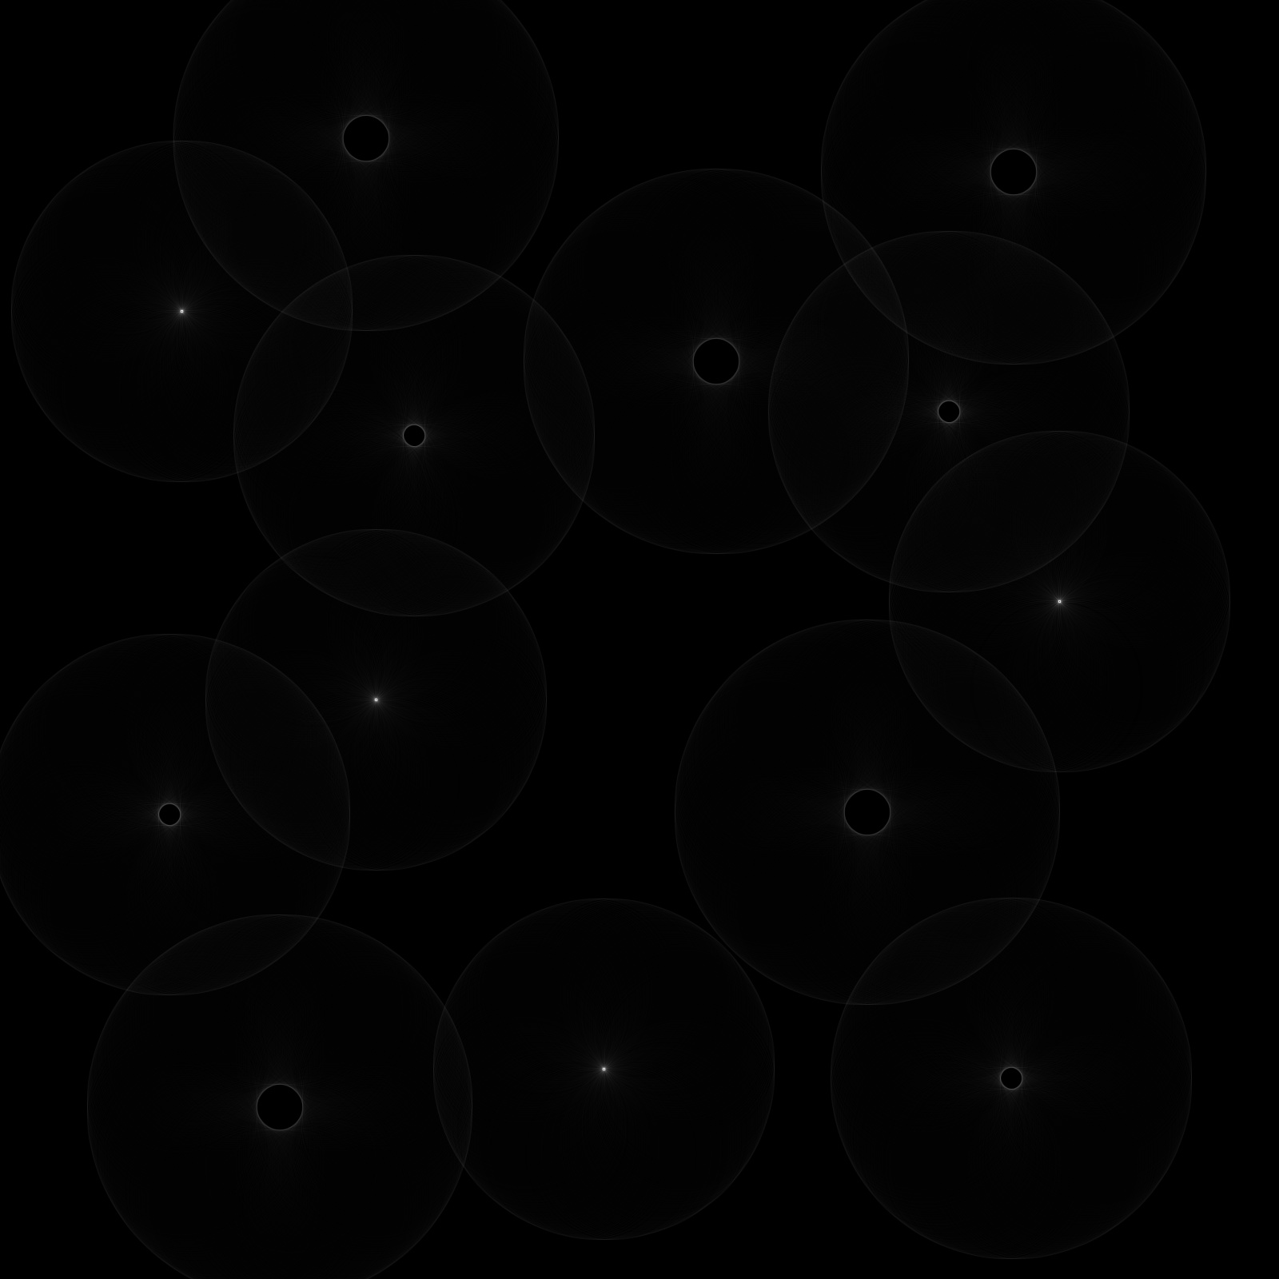  
  
Hough for 25 piasters Coin  
  
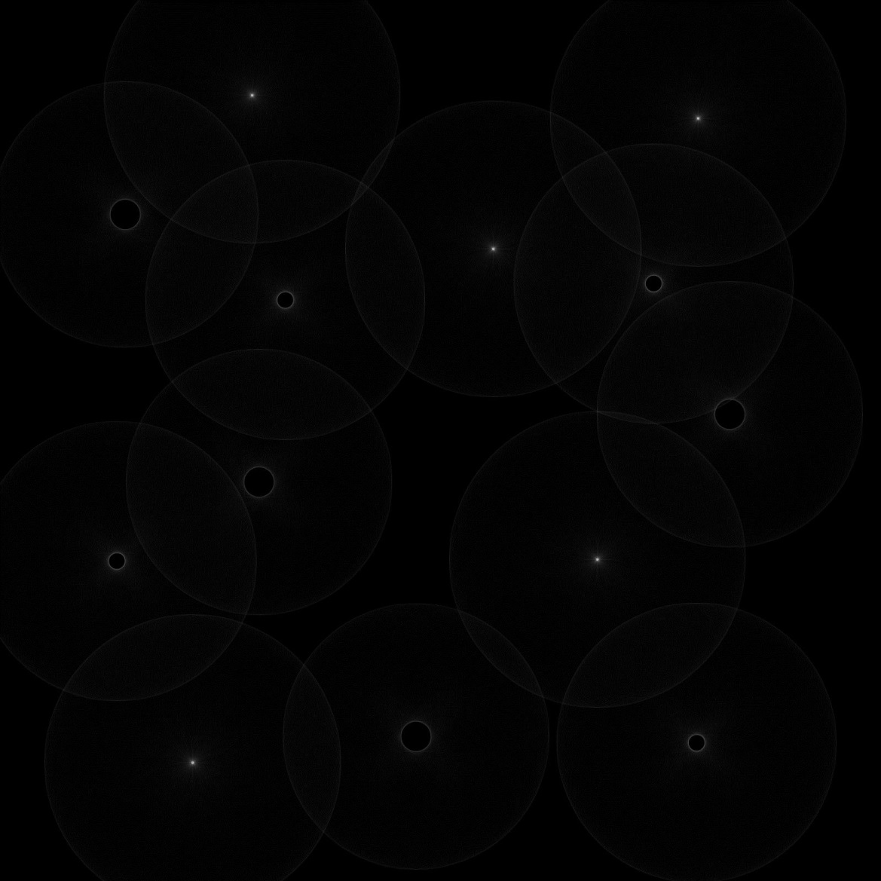

Hough for 100 piasters coin

# Experimenting on detecting circles post processing the Hough

Extracting the circle centers was a tricky issue  
first we assumed that all the center points have single value and to be maximum but the assumption proved to be wrong then tried saving the imahe and importing it again so to eliminate the voting accumulation effect on the Hough Space bu that also have proven to be useless finally we settled to have an intensity margin of 40 unit to the maximum intensity pixel to which the rest of the circles would appear without having any of the least voted points and it worked perfect